BASE LINE SURVEY QUESTIONS
Dear students,
First of all, let us say that we are looking forward to seeing you all in Greece in April. As we are preparing the material for your visit, we would like to ask you a few questions about the activities you are going to do while in Greece. These activities include visits to ancient and modern sites in Athens and Piraeus, a bit of Etymology, Philosophy and Mathematics (remember, you are visiting Greece), a visit to ancient mines to delve into the ancient Greek sustainable technology and a visit to a farm using natural farming methods and belonging to a social cooperative enterprise. Please answer the following questions to your best knowledge without searching for/ googling the right answer. You will be asked to answer the same questions again after your visit.
Looking forward to seeing you all in April
The Greek Pedagogical team
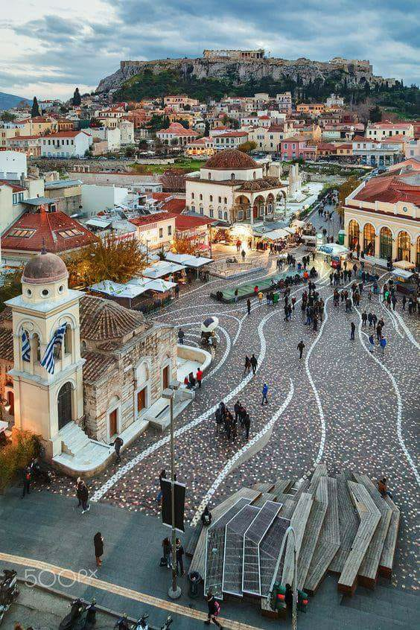
THE CITY AND PORT OF PIRAEUS
- Piraeus is the largest passenger port in Europe and the second largest in the world.
YES/NO/ DON’T KNOW
- Piraeus used to be an island in prehistoric times YES/NO/ DON’T KNOW
- It was first inhabited 3,000 years ago. YES/NO/ DON’T KNOW
- The basic parts of an ancient theatre are: the scene, the orchestra and the seats
YES/NO/ DON’T KNOW
- Is this a neoclassical building? YES/NO/ DON’T KNOW
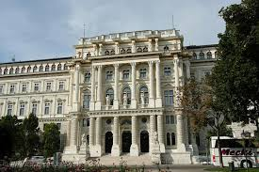

ANCIENT ATHENS
Are the following statements True or False?
- This is a picture of the Acropolis of Athens T/F
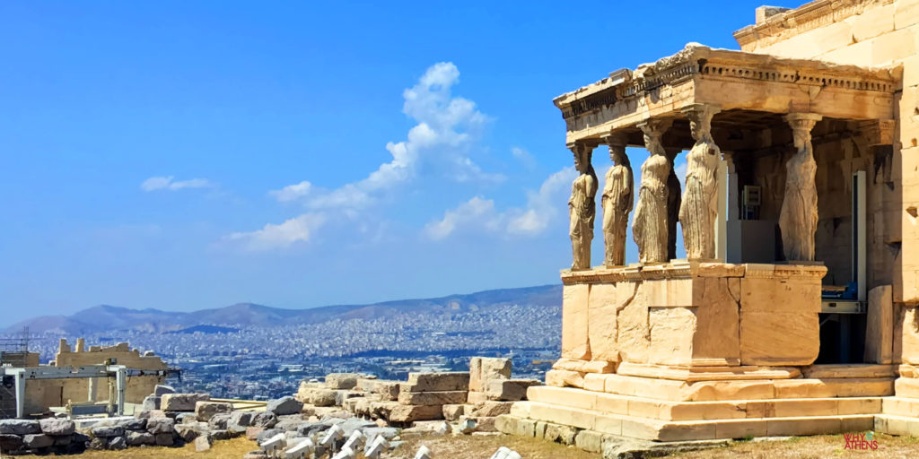
- This temple is called Parthenon. T/F
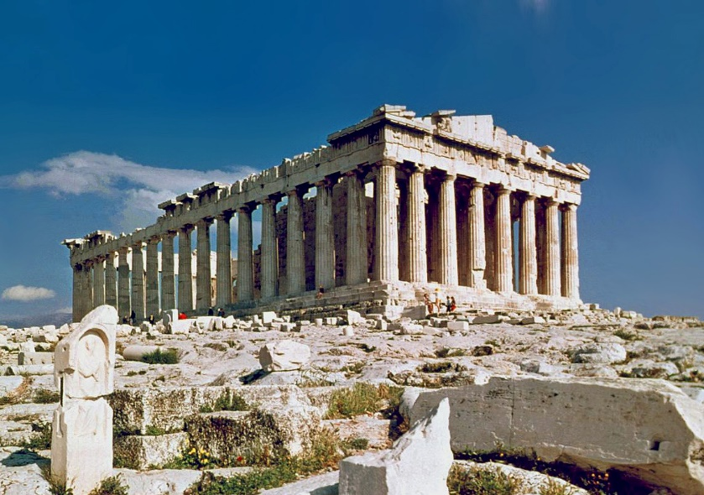

- There was no separation of powers (legislative, executive, and judiciary) in ancient Greek Democracy T/F
- All the ancient god temples have been transformed into Christian churches. T/F
- Many of the Acropolis statues and reliefs are permanently exhibited in the British Museum. T/F

ETYMOLOGY
Do the following English words derive from Ancient Greek or from Latin?
Demigod LATIN GREEK DON’T KNOW
Geology LATIN GREEK DON’T KNOW
Geography LATIN GREEK DON’T KNOW
History LATIN GREEK DON’T KNOW
Abdomen LATIN GREEK DON’T KNOW
Mathematics LATIN GREEK DON’T KNOW
Geometry LATIN GREEK DON’T KNOW
Trigonometry LATIN GREEK DON’T KNOW
Anima LATIN GREEK DON’T KNOW
Politics LATIN GREEK DON’T KNOW
Democracy LATIN GREEK DON’T KNOW
Equinox LATIN GREEK DON’T KNOW
Catastrophe LATIN GREEK DON’T KNOW
Latex LATIN GREEK DON’T KNOW

PHILOSOPHY
Mark the following statements as True or False
- Natural Philosophy was the first stage in the evolution of Greek philosophy T/F
- It was an attempt to interpret the world and nature referring to myths, religion and tradition T/F
- Natural Philosophers combined philosophy with science in an effort to find the truth about the origin and/or the essence of the world T/F
- Their philosophy is “homocentric” (focusing on human beings) rather than “cosmocentric” (focusing on the world) T/F
- They also dealt with questions regarding knowledge, society, ethics and politics T/F

MATHEMATICS
- If we double the length of the side (5 cm) of a square, then the area (A) of the new square will be:
5 cm

- 2A
- 5A
- 4A
- 10A

- If we triple the length of the side of a square with area A₁=3cm², then the area (A₂) of the new square will be:
A₁=3 cm²
- A₂= 6 cm²
- A₂= 9 cm2
- A₂= 12 cm2
- A₂= 27 cm2

LAVRIO
- There were three social classes in ancient Athens: citizens, immigrants and slaves. YES/NO/ DON’T KNOW
- There was a well-organized educational system in ancient Athens for boys and girls. YES/NO/ DON’T KNOW
- Collecting and recycling rainwater was indispensable in the area of Lavrio because the climate is dry. YES/NO/ DON’T KNOW
- Ancient Athenians had invented a kind of cement to waterproof their rainwater tanks. YES/NO/ DON’T KNOW
- Marble was quarried at Lavrio in ancient times using special technology. YES/NO/ DON’T KNOW
SOUNIO
- Do you know how the Aegean Sea (where the most famous Greek islands are) got its name? YES/NO/ DON’T KNOW
- The temple of Poseidon at Cape Sounio was built only for religious and not for defensive reasons. YES/NO/ DON’T KNOW
- Guards at Cape Sounio could not send messages directly to Athens because there was no such technology at the time. YES/NO/ DON’T KNOW
- The sun is always bad for your health. YES/NO/ DON’T KNOW

NATURAL FARMING
Which of the following statements apply to Natural Farming?
- Farmers cultivate only local crops
- Farming can be done in greenhouses
- It can be done on large scale
- The farmer chooses which crops to grow
- It is a sustainable way of growing food in that there is little or no intervention on the part of the farmer

SOCIAL ECONOMY/ SOCIAL ENTERPRISES
- Social Economy accounts for …… of all businesses in Europe
- 10%
- 30%
- The primary objective of the traditional social economy enterprises is to
- Obtain a return on investment
- Serve the members of the enterprise
- Decide if the following are objectives of a social economy enterprise
- To contribute to the EU’s employment YES/NO
- To reinforce social cohesion YES/NO
- To make profit for the owners YES/NO
- To promote regional and rural development YES/NO
- To replace social security regimes YES/NO
- To ensure environmental protection YES/NO
- To promote industrial development YES/NO

