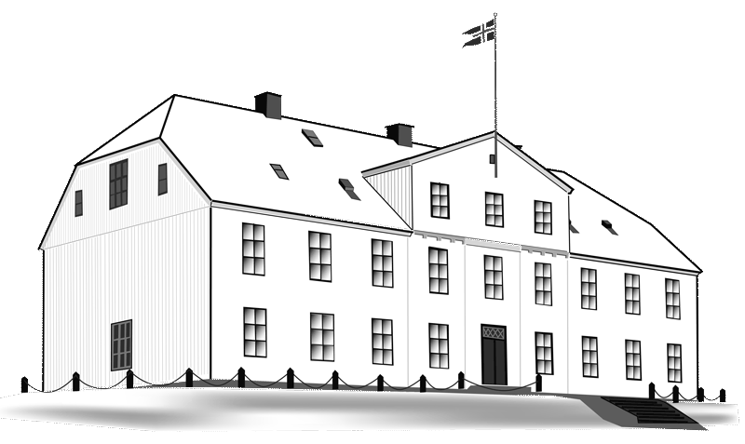
Menntaskólinn í Reykjavík

This is to certify that
«Names»
attended the kick-off meeting of the Erasmus+ project:
ROOTS
Routes to Outdoor Oriented Teaching and Sustainability
2017-1-IS01-KA219-026517_1
September 24th – 26th 2017

Reykjavík, September 26th 2017

_____________________________ ________________________
Jóhanna Arnórsdóttir Yngvi Pétursson
Coordinator Headmaster

