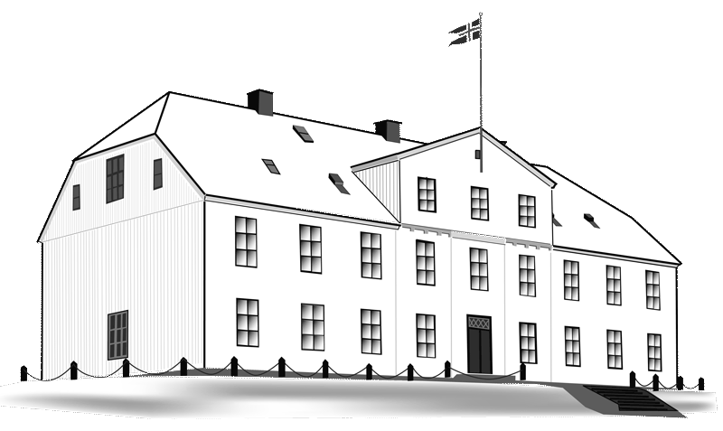
Menntaskólinn í Reykjavík

Certificate of expenses
Kick-off meeting of the ROOTS project
2017-1-IS01-KA219-026517_1

This is to certify that ____________________ delegation of ________________ has payed ____________ € on excursions and meeting costs during the Erasmus+ meeting in Menntaskólinn í Reykjavík in the period of September 24th to 26th 2017.
Reykjavík, September 26th 2017

_____________________________ ________________________
Jóhanna Arnórsdóttir Yngvi Pétursson
Coordinator Headmaster

