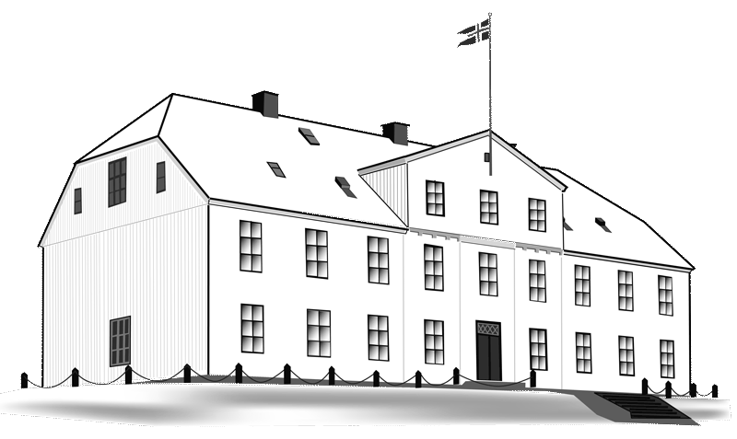
Menntaskólinn í Reykjavík
21th June 2017

Invitation to a Transnational Project Meeting of the project:

Routes to Outdoor Oriented Teaching and Sustainability
Erasmus+ Project 2017-2020
Reference no: 2017-1-IS01-KA219-026517

It is our honour to invite our partners from

Ralleio Geniko Lykeio Thileon Peiraia, Greece

Hersby Gymnasium, Sweden

IES Torrellano, Spain

Gymnazija Jurija Vege Idrija, Slovenia

Menntaskólinn í Reykjavík, Iceland

to the first meeting of the project taking place in Iceland
September 24th - 27th 2017

The topic of the meeting is: Project coordination. Organization and distribution of tasks and responsibilities during the first period of the project.

With kind regards,

__________________________
Yngvi Pétursson, principal
Menntaskólinn í Reykjavík

