STUDY KIT FRAMEWORK
Title: The historical farm Stöng and the waterfall Gjáfoss.
Topic: History and Geology of the valley Þjórsárdalur.
Keywords: Settlement, farming, ruins, archaeological excavation, volcano, pumice, lava, basalt columns, waterfall, spring water.
Subject: History, Geology, Archaeology, Culture.
Cross-curricular Topic: Outdoor activities, healthy lifestyle, sustainability.
Level: Upper Secondary School
Age: 16-
Number of students: 10-20
Duration in minutes: 120 minutes
Place (classroom, outdoor etc.): Outdoor
Author: Helmut Hinrichsen and Jóhanna Arnórsdóttir
School: Fjölbrautaskólinn við Ármúla and Menntaskólinn í Reykjavík, Iceland
Language: English, Icelandic
Overview: Participants will visit the excavation site of the historical farm Stöng in Þjórsárdalur, observe a long house and farm sheds from the end of the Wiking Age. On the trail from the ruins of the farm house to the waterfall at Gjáin they will observe the impact of an extensive Plinian eruption of the volcano Hekla in 1104 on the settlement of the valley Þjórsárdalur.

Objectives:
- To observe excavations of farm houses from the time of settlement.
- To learn about the life and work of the first settlers.
- To understand the impact of a volcano eruption on the environment.
- To observe volcanic rock as lava, pumice and basalt columns.
- To learn about GPS and determine the exact position of a place.
- To promote a healthy lifestyle.
Learning material and tools: Smartphone, camera and task list.
Preparation: Participants are prepared by introducing the navigation positioning system GPS. The teacher will prepare a task list with questions about the places being visited. Participants will install a navigation app (like Wikiloc) on their smartphones and are instructed how to track a route and mark waypoints.
Evaluation: The answers on the task list.
Extra material: Map of excavations and geological history of the valley Þjórsárdalur (Árbók Ferðafélag Íslands 1996, only in Icelandic).
Detailed description/instruction:
The aim of this project is to make students see and understand how people lived at the time of settlement and what impact the Plinian eruption of the volcano Hekla in 1104 had on the valley Þjórsárdalur. Students work in groups of 2-3.

Participants start their hike at the parking place on the southern side of the river Rauðá from where they hike to the excavation site of the settlement farm Stöng. After observing the long house, farm sheds and stables they use their smartphones to follow the trail to the waterfall Gjáfoss. Participants track their own trail and mark waypoints of historical and geological interest. On the way they observe signs of the Plinian eruption from 1104, collect pumice and discover volcanic formations as basalt columns. They use their smartphones also to take photos of places of interest.

Trail from the excavation site at Stöng to the waterfall Gjáfoss and surrounding.
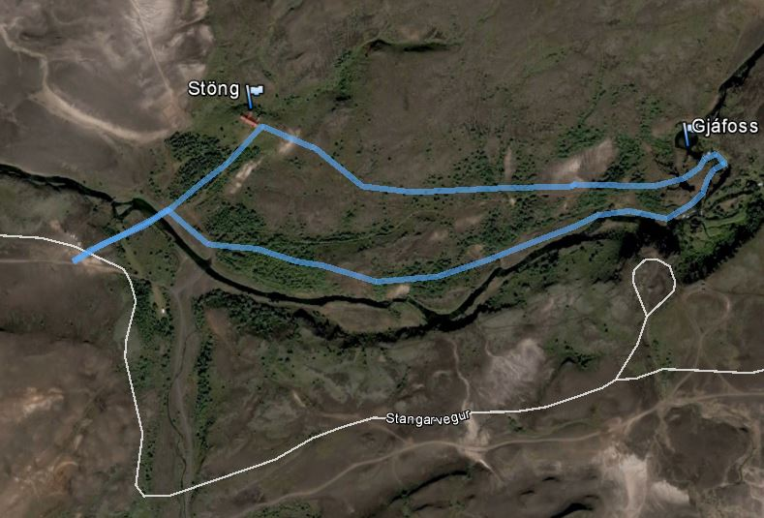

Names of participants:

Task 1 | Name of place: | Date: | Time: | GPS:
Excavation site at Stöng (short description and photos). Mark the place as waypoint.

The farm house of Stöng is larger than farm houses in later centuries. Explain why.

Taks 2 | Name of place: | Date: | Time: | GPS:
Find signs of the impact of volcano eruptions on the trail (photos). Mark the place as waypoint.

Find a peace of pumice and proof that it floats on water (photo/video).
Please leave the piece of pumice at the site.

Task 3 | Name of place: | Date: | Time: | GPS:
Observe the waterfall Gjáfoss and it’s surrounding (photos). Mark the place as waypoint.

Take a photo of basalt columns. How do basalt columns form?

Save your track you have hiked.

